We know you and
we know what you do...
- You’re the intake worker who quietly listens to your clients and suggests the most helpful solution.
- You’re the worker who weatherizes the home of the elderly couple down the street.
- You’re the program director who is responsible for the quality of programs offered and outcomes achieved.
- You’re the employment and training specialist who helps the laid-off worker find a new job.
- You’re the van driver who gets the Head Start kids to school or the cook who fixes their meals.
- You’re the board member who volunteers your time to help those in need.
- You’re the elected official or corporate representative who is trying to improve the conditions in your community.
- You’re a community action partner who helps people, changes lives, and strengthens communities.

And we’re the organization that helps you do it!
… the organization that helps you get the funding so you can continue to change lives and strengthen communities.
… the organization that provides the training and technical assistance that are so important for your success.
…the organization that educates the public and elected officials about the work of community action and advocates on behalf of you and the clients you serve.
…the organization that keeps you informed about issues related to poverty, the exemplary work of our network, and upcoming training opportunities.
We know you are committed to creating positive change in the lives of those who live in poverty.
ACAAA is the voice of
Community Action in Arkansas.
You Make a Difference!
Join ACAAA Today
January 1 through December 31, 2009.

Help make your state association of Community Action Agencies more effective by becoming a member today!

Annual Affiliate Membership Dues
(check the one that applies)

___ CAA Executive Director $50.00

___ CAA Management $20.00
(supervise at least 2 people)

____ Other CAA staff $5.00

____ Friends of Community Action $5.00
(board members & non-community action staff)

Name: ___________________________________
Title:_____________________________________
Agency:__________________________________

Preferred Mailing Address:
(for delivery of “The Action Newsletter”)

Street/P.O. Box ____________________________

City: ___________________ State: ____________

Zip: ________________

Phone: _________________ Fax: _____________

E-Mail: ___________________________________

Return membership dues and forms to :
ACAAA
300 Spring St., Suite 1020
Little Rock, AR 72201

ACAAA

Arkansas
Community
Action
Agencies
Association

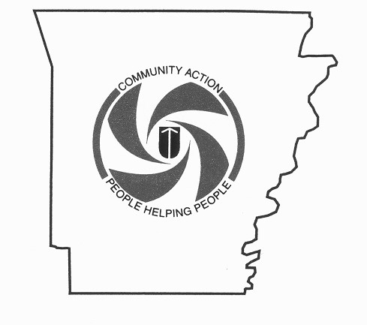

Strengthening the Power of
Community Action
in Arkansas

Come Grow With Us!

ACAAA
is making a difference
in the state of Arkansas,
strengthening the power of
community action agencies.

If you would like to find out more about the opportunities
ACAAA offers, contact us today or visit our website!

ACAAA
300 Spring St., Suite 1020
Phone: 501-372-0807
Fax: 501-372-0891
E-mail: acaaa@aristotle.net
www.acaaa.org
What Our Members say about
ACAAA…
“One of the many benefits of membership is the Association’s newsletter, which is vital to me. It keeps me informed about what’s going on with other community action agencies and gives me ideas about new approaches and programs we might consider for those in need in our counties.”
- Don Ramey, former executive director of Crawford– Sebastian Community Development Council, Fort Smith

“ I wanted to be a member because I was struck, after reading the newsletters, by the impact you’re having on the lives of so many people in communities all across Arkansas, and I wanted to be a part of that.”
-Laura Newman, public relations executive, Little Rock

“ I became a member because I wanted to network with all the people I can who can influence a positive difference in my area.”
- Fairy Armstrong, community activist, Brinkley

